
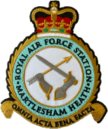

SATURDAY 11th APRIL 2026 @ 2.30pm
Martlesham Heath Aviation Society
FILM SHOW presents:
Charity Number : 1184409




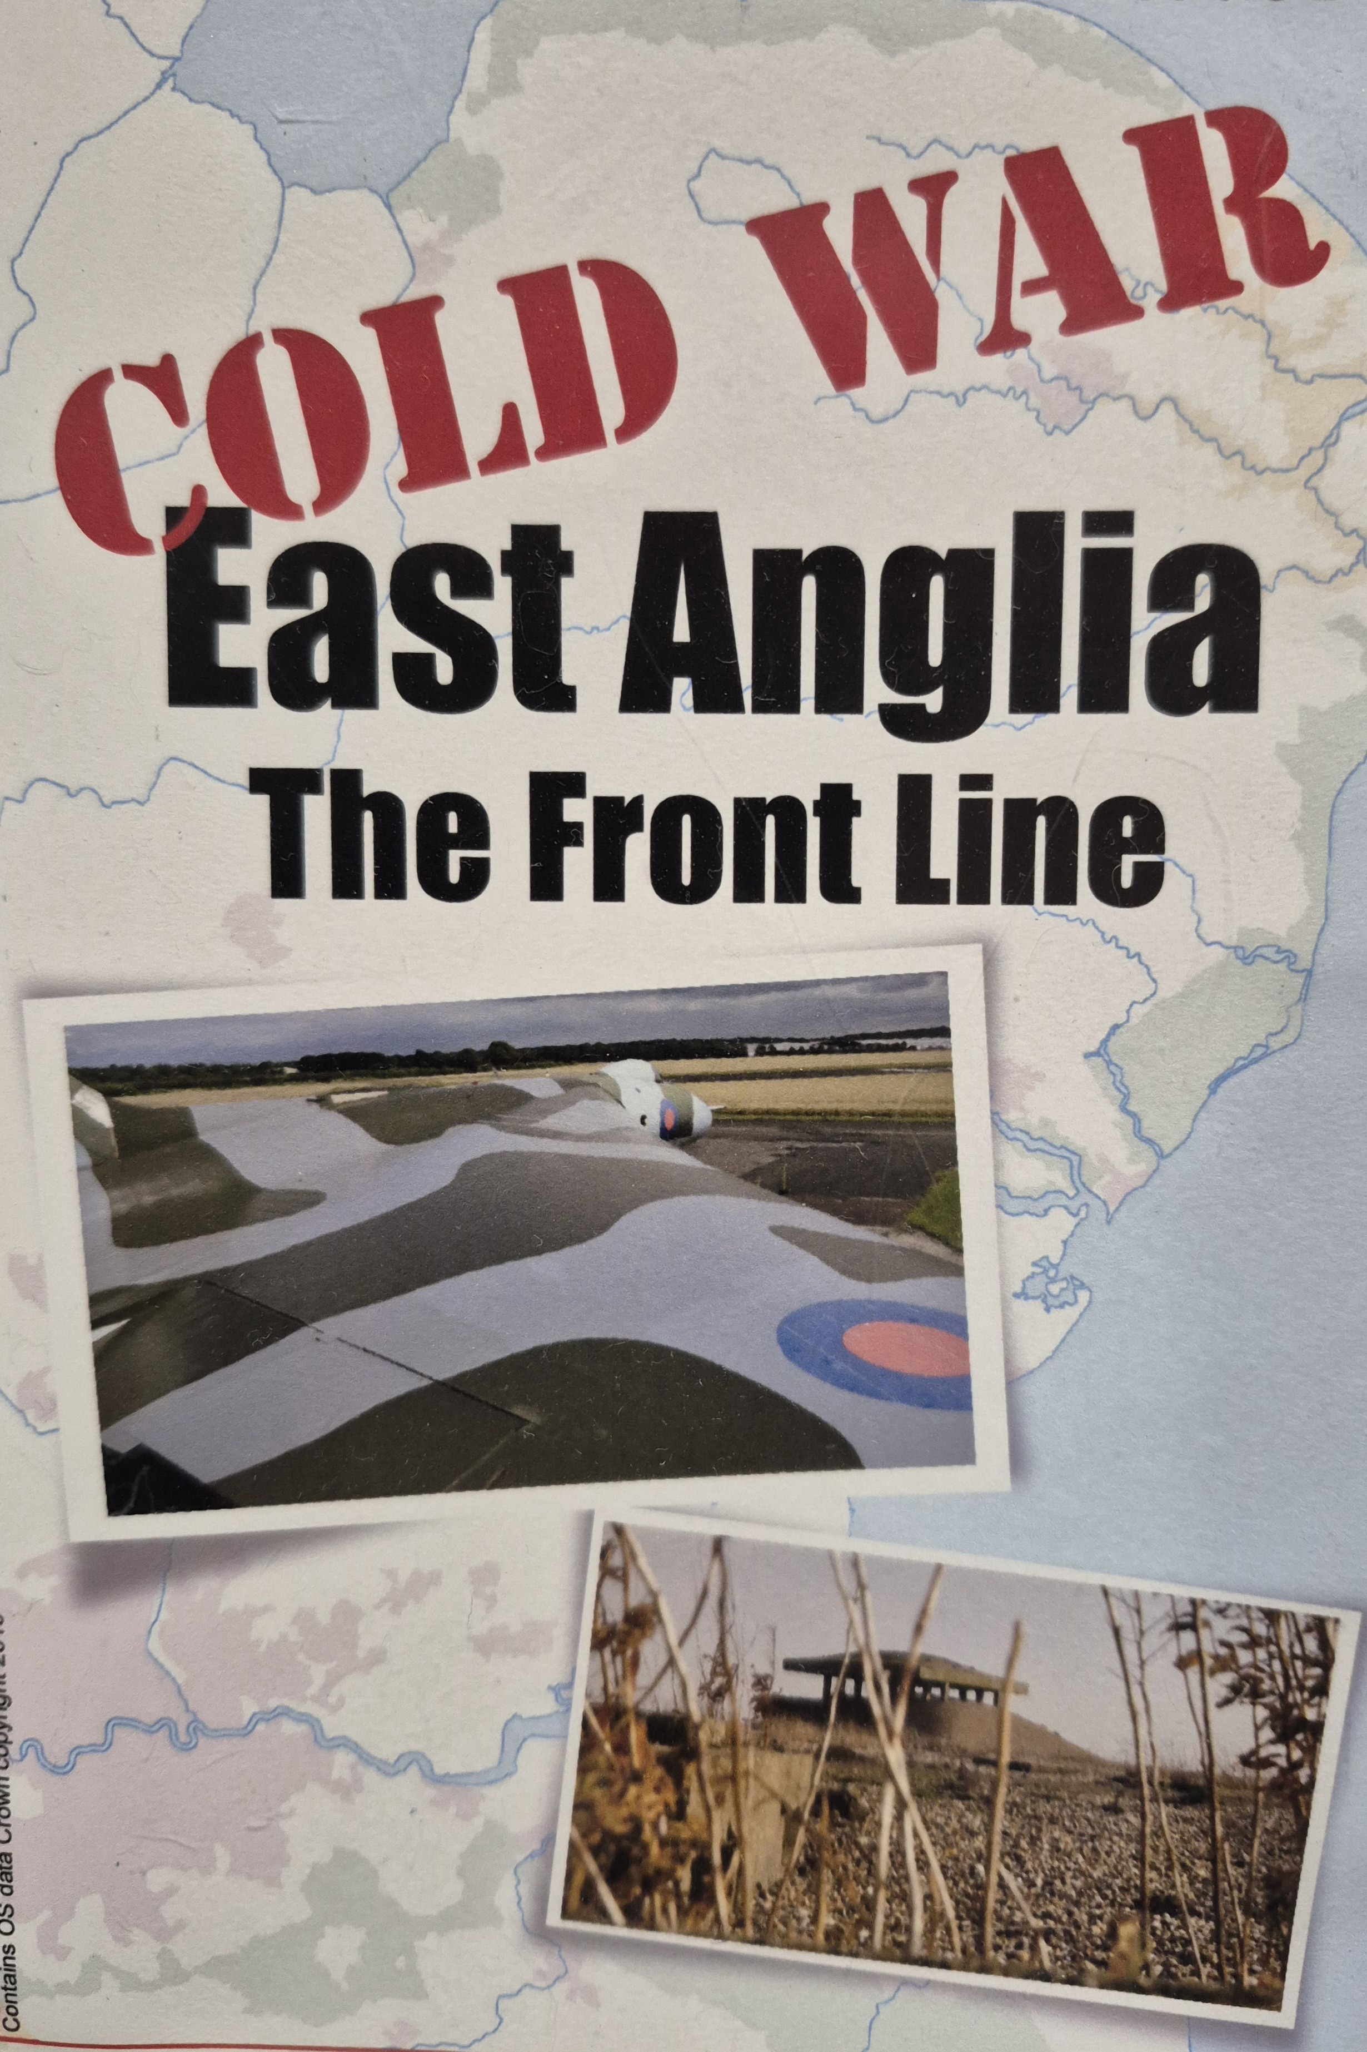
Our second film provides an insight into the mysterious and widespread local infrastructure above & below ground put in place to monitor and operate the West’s response in East Anglia during the Cold War period.
VENUE:
Martlesham Heath Community Centre
Felixstowe Road Martlesham IP12 4PB
MHAS General information:
www.mhas.org.uk
Ticket Enquiries: Call Howard on 074 234 047 04. Buy at our meetings (Cash or Card), or call and Order/Pay by Bank Transfer.

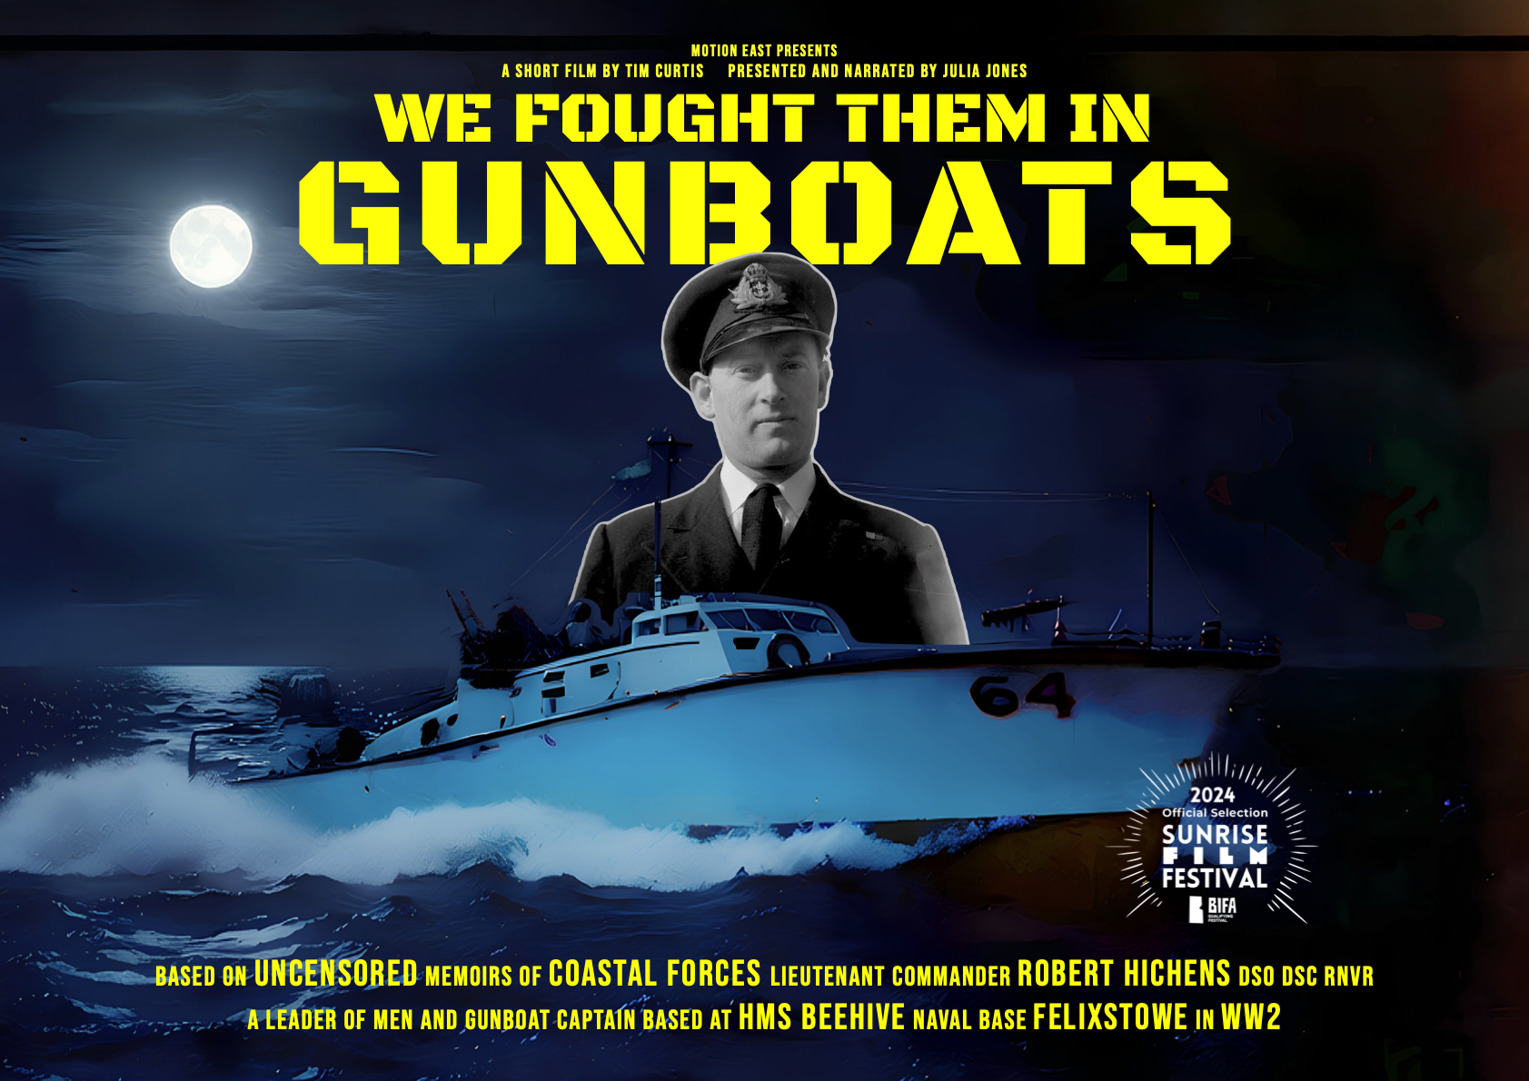
“We Fought Them in Gunboats” and
“Cold War East Anglia – The Front Line”
This will be an all ticket event available on a first come, first served basis.
The MHAS Film Show presents two films:
The renowned TV & Film maker, Tim Curtis, brings us the compelling story of the “Spitfires of the Sea” – the Motor Gun Boats operating out of Felixstowe in WW2.

This is a ticket only event
£6 members,
£8 non-members

V2_1 30/1/2026

